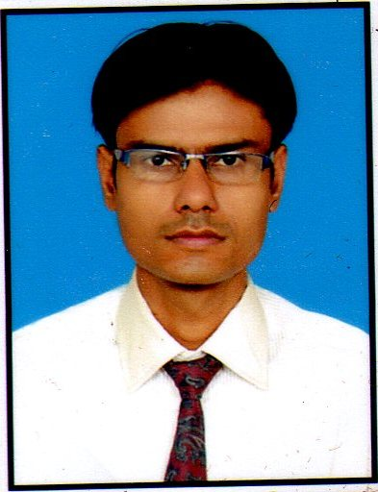
NISHANT KUMAR SOLANKI

Gujarati Gali, Bengali Para, New Sarkanda,
Bilaspur (C.G.) 495001
E-mail: PHARMANISH@GMAIL.COM
+91–9907981765, 9685567834

OBJECTIVE :

Seeking a responsible and challenging opportunity that would utilize and enhance my skill, where I can devote my creative capability through dedicated hard work and resources of the company to achieve a combined growth.

EXPERIENCE

EMPLOYER:
- Work In ZydusCadila, Ahemdabad,In Tablet section (In Dispensing and Mixing ) Production Unit
- Work in Apollo Hospital Bilaspur (c.g.) (Fom Feb. 2012 to Oct. 2013) as a Pharmacist.
- Work in Haffkin Pharmaceuticals (Maharashtra Govt.) As a trainee in Syrup unit (From Oct. 2013 to Jan. 2014).
- Work in Apollo Hospital Bilaspur (c.g.) (From Feb. 2014 to Apr. 2016) as an Incharge.

PRESENT WORK: Work in New Korba Hospital Korba (C.G.) (From Apr. 2016) as a Pharmacy Incharge and Auditor.

PROFILE :

Designation Work as a Pharmacy Incharge with purchasing and marketing.
Work as a Hospital Auditor.

Job Profile:
- Updating the medicine as per hospital requirement.
- Responding to drug related queries of all health care professionals.
- Documentation and updating of work and department.
- Hospital Audit work related medicine and documentation.
- Pharmacy audit and data updating.
- Stock updating and medicine, equipments management.
- Purchasing as per requirement basis.
- Training of staff as per their performance.
- Marketing and purchasing of healthcare products.

HOBBIES :

Listening to music, cooking and watching movies

EDUCATIONAL QUALIFICATIONS
Degree | University / Board | Year of Passing | Class
B.Pharm | CSVTU. Bhilai / C.E.C. Bilaspur (C.G.) | 2008-2011 | 71.24 %
D.Pharm | CSVTU. Bhilai / C.E.C. Bilaspur (C.G.) | 2006-2008 | 65.33 %
H.S.C | C.G. Board of Education, Raipur (C.G.) | 2006 | 56.2 %
S.S.C | C.G. Board of Education, Raipur (C.G.) | 2002 | 62.2 %

PROJECTS HANDLED:

B.Pharm: “Formulation development of eucalyptus oil microemulsion for intranasaldelivery”.
This formulation is used to treat migrane. In this formulation the main active pharmaceutical ingredient is eucalyptus oil. This formulation should be used through intranasal delivery.

D.Pharm: 3 months internship in District Government Hospital, Bilaspur (C.G.)

COMPUTER PROFICIENCY
M.S. OFFICE (2007 and 2010) Word, Excel, PowerPoint and Internet Browsing.

ACCOMPLISHMENTS

- Industrial Training in Vama Pharmaceuticals, Nagpur (One Month).
- Participate in National Seminar on “Potential Approaches in Herbaceuticals”.
- Handling of report of adverse drug reaction, hypoglycaemia.
- Active participation in cultural activities and sports

PERSONAL INFORMATION

Date of Birth 21st Feb 1987
Gender Male
Nationality Indian.

DECLARATION
I hereby declare that all the information provided by me in resume is factual and correct to the best of my knowledge and belief.

Place : Yours Sincerely,
Date: Nishant Kumar Solanki

